**Logical reasoning Test (set 1)**

**Company name: Deloitte No. of Question: 25**

**1:**

Select the correct combination of mathematical signs to replace * signs and to balance the given equation.

5*6*5*9*15

1. ˗ ÷ = +
2. + ˗ = ×
3. + ˗ = ÷
4. × ÷ + =

**Answer:** option d

**Solution:**

Given equation = 5*6*5*8*15

From option (4), putting the given signs:

⇒5 × 6 ÷ 5 + 9 = 15

⇒ 6 + 9 = 15

⇒ 15 = 15

Hence, the correct symbols are ‘× ÷ + =’.

**2:**

In the following question, select the number which can be placed at the sign of question mark (?) from the given alternatives.

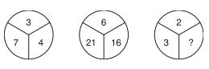

1. 20
2. 2
3. 16
4. 4

**Answer:** option d

**Solution:**

From the given question, the number in the middle segment is the product of the two numbers in the same segment in the other two circles.  
Thus, 3×2 = 6,

7×3 = 21

and 4×4 = 16.

So, missing number = 4

**3:**

Which of the following figure is formed by a given figure?

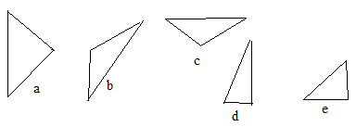

1. 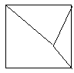
2. 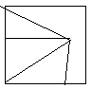
3. 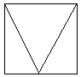
4. 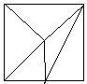

**Answer:** option d

**Solution:**

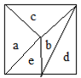

**4:**

Select a figure amongst the four alternatives, which when placed in the blank space of figure (X) would complete the pattern.

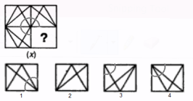

1. (1)
2. (2)
3. (3)
4. (4)

**Answer:** option c

**Solution:**



Figure in option 3 indicates the figure required to complete the question figure.

**5:**

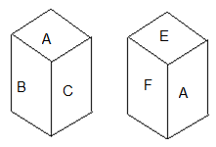

If D is on the bottom of the dice then which side is on the top of the dice?

1. F
2. E
3. A
4. B

**Answer:** option c

**Solution:**

Neighbor sides of A = B, C, F, E.

A is opposite to D.

So A is on the top of dice.

**6:**

Answer the following question according to the following code?

A @ B means that A is the mother of B.

A $ B means that A is the brother of B.

In F @ S $ Q, How F is related to Q?

1. Father
2. Mother
3. Maternal Uncle
4. Uncle

**Answer:** option b

**Solution:**

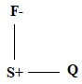

**7:**

Find the number of triangles present in this following figure?

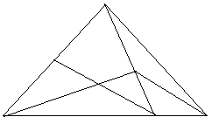

1. 15
2. 13
3. 11
4. 9

**Answer:** option b

**Solution:**

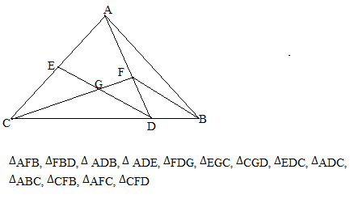

**8:**

In the row of forty girls, Ayesha sits third to the right of Shikha, who is sitting ninth in the row from the left. Find the position of Ayesha in the row from right?

1. 28
2. 27
3. 29
4. Information is incomplete

**Answer:** option c

**Solution:**

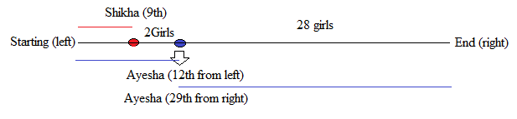

**9:**

Find the Second word according to the dictionary?

1. Stilt
2. Stifle
3. Stink
4. Stingy

**Answer:** option a

**Solution:**

1) Stifle 2) Stilt 3) Stingy 4) Stink

**10:**

Find the missing number?

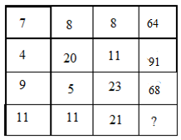

1. 100
2. 95
3. 142
4. 148

**Answer:** option c

**Solution:**

64 = 7 × 8 + 8

91 = 4 × 20 + 11

68 = 9 × 5 + 23

142 = 11 × 11 + 21

**11:**

Find the missing term?

26, 40, 68, 110, 166, ?

1. 225
2. 236
3. 264
4. 284

**Answer:** option b

**Solution:**

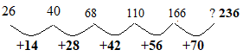

**12:**

Find the word which cannot be formed using HUMBLING?

1. NUMB
2. LUNG
3. GLUM
4. BLUE

**Answer:** option d

**Solution:**

Only BLUE cannot be formed using HUMBLING.

**13:**

Rahul started from point A and travelled 8 km towards the North to point B, he then turned right and travelled 7 km to point C, from point C he took the first right and drove 5 km to point D, he took another right and travelled 7 km to point E and finally turned right and travelled for another 3 km to point F. What is the distance between point F and B?

1. 1 km
2. 2 km
3. 3 km
4. 4 km

**Answer:** option b

**Solution:**

Rahul walking directions are

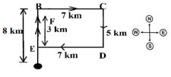

Here, AB = 8 km, BC = 7 km

CD = 5 km, DE = 7 km

EF = 3 km, BE = 5 km

Hence, BF = BE – EF = 5 – 3 = 2

So, option (2) is the correct answer.

**14:**

In the following question, answer word is exactly the water image of the given word.

DL2CA34OO

1. 
2. 
3. 
4. 

**Answer:** option a

**Solution:**



So, option (1) is the correct answer.

**15:**

In the following questions, two statements are given each followed by two conclusions I, II, III and IV. You have to consider the statements to be true even if they seem to be at variance from commonly known facts. You have to decide which of the given conclusions, if any, follows from the given statements.

**Statements:**

All jungles are trees.

All trees are roads.

All roads are houses.

All houses are buildings.

**Conclusions:**

I. All trees are houses.

II. Some buildings are roads.

1. Only Conclusion I follows
2. Only Conclusion II follows
3. Either Conclusion I or II follows
4. Both Conclusions I and II follow

**Answer:** option d

**Solution:**

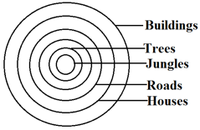

Conclusions:

I. All trees are houses. (√)

II. Some buildings are roads. (√)

So, option (4) is the correct answer.

**16:**

A word is represented by only one set of numbers given in the alternatives. The sets of numbers given in the alternatives are represented by two classes of alphabets as in two matrices given below. The columns and row of Matrix I are numbered from 0 to 4 and that of Matrix II are numbered from 5 to 9. A letter from these matrices can be represented first by its row and next by its column e.g., ‘N’ can be represented by 02, 43, 58 etc. Identify the set for the word ‘DECO’.

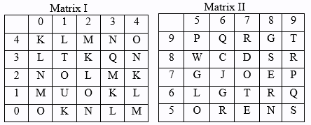

1. 87, 78, 86, 55
2. 87, 57, 86, 21
3. 87, 57, 86, 34
4. 86, 57, 14, 45

**Answer:** option b

**Solution:**

D = 87

E = 57

C = 86

O = 21

So, option (B) is the correct answer.

**17:**

In the following question, select the number related to the given options.

520 : 738 : : ? : 350

1. 220
2. 222
3. 230
4. 248

**Answer:** option b

**Solution:**

520 = 8×8×8+8 = 512+8

738 = 9×9×9+9 = 729+9

350 = 7×7×7+7 = 343+7

∴ ? = 6×6×6+6 = 216+6=222

So, option (2) is the correct answer.

**18:**

Which of the following Venn diagram shows the best relation of Cricket, Football, and Game?

1. 
2. 
3. 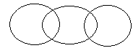
4. 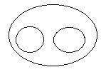

**Answer:** option d

**Solution:**

Venn diagram 4 shows the best relation of cricket, football, and game.



**19:**

In the following question, select the related number from the given alternatives.

1/3 : 2/3 :: ?: 60

1. 20
2. 30
3. 10
4. 120

**Answer:** option b

**Solution:**

In the given question, 30is half of 60, and 1/3 is half of 2/3.

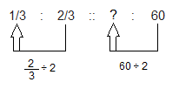

**20:**

Select the related number from the given alternatives?

2: 31::3: ?

1. 290
2. 242
3. 243
4. 200

**Answer:** option b

**Solution:**

31 = 25 – 1

242 = 35 - 1

#SolutionHindi:

31 = 25 – 1

242 = 35 - 1

**21:**

In a certain code language,

Go to Delhi written as @7P %4j $20p

Going take drink written as %4l $20f @7i,

Find a code for danger?

1. %4j
2. $20f
3. $20p
4. %4s

**Answer:** option d

**Solution:**

@ for g, % for d, and $ for t first letter of a coded language.

The second letter of code language is the position value of every word.

The third letter of code language is the predecessor of the last letter of the word.

**22:**

‘COUNTING' written as 'DQXRYOUO' then find the code for 'PROPERTY'?

1. QTRTJXZG
2. QTNTJXAG
3. QTROJXAG
4. QTRTJXAG

**Answer:** option d

**Solution:**

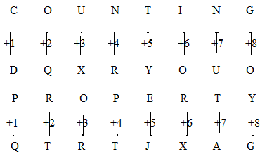

**23:**

Find the odd word out?

1. Crow
2. Sparrow
3. Swan
4. Peacock

**Answer:** option c

**Solution:**

The only swan lives in water.

**24:**

Select the odd letters from the given alternatives.

1. EHK
2. ZBD
3. LOR
4. SVY

**Answer:** option b

**Solution:**

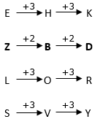

Thus ZBD are the odd letters.

**25:**

If 45 % 11 = 7, 59 % 34 = 7 then what is the value of 55 % 4 = ?

1. 6
2. 40
3. 45
4. 50

**Answer:** option a

**Solution:**

45 % 11 = 7

⇒ 4 + 5 – 1 – 1 = 7

59 % 34 = 7

⇒ 5 + 9 – 3 – 4 = 7

Similarly,

55 % 4 =

⇒ 5 + 5 – 4 = 6

Thus 55 % 4 = 6